HTTP 5126 – Database Assignment 5.24W

# Assignment 5-Retrieving Data from Multiple Tables (Evneet Kaur n01649956)

## Part 1: What are the sales for a particular item? (1%)

1. Select *date* (from *sales*), *item* (from *stock* *items*) to get the items with a value of 1014.

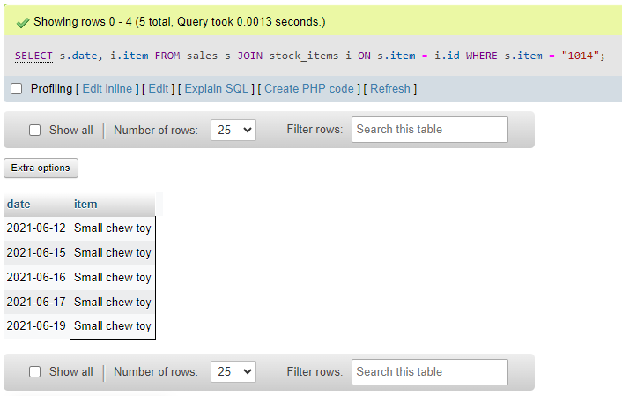

1. Find the employee numbers who sold item cat (feline) water dish. Include employee number, item number, category and item.

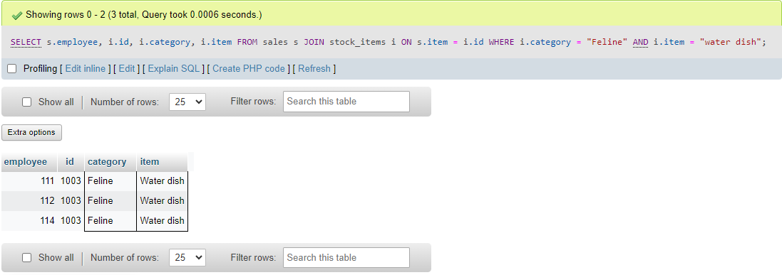

## Part 2: What are the sales for a particular team member? (1%)

1. Select *date* (from *sales*), first and last name (from employees), *item* (from *sales*) to show the sales from the employee with a value of 111.

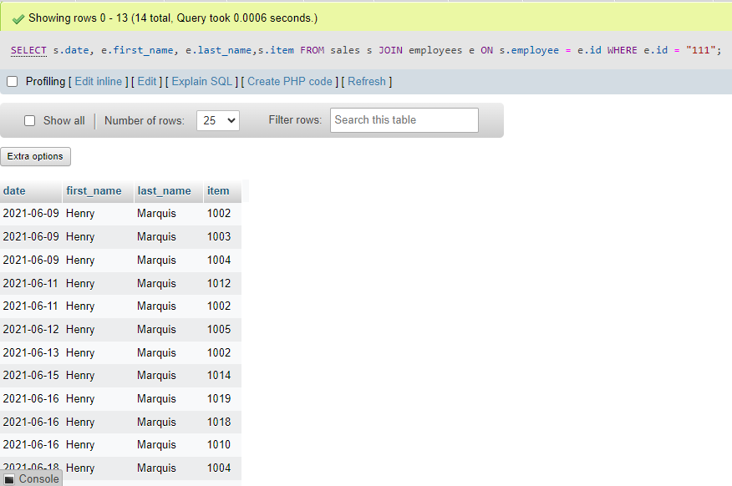

1. Find all sales by employees who have a SIN number that starts with either 258, 456 or 753. Include employee name (in one column), SIN, role, and item. Use right join.

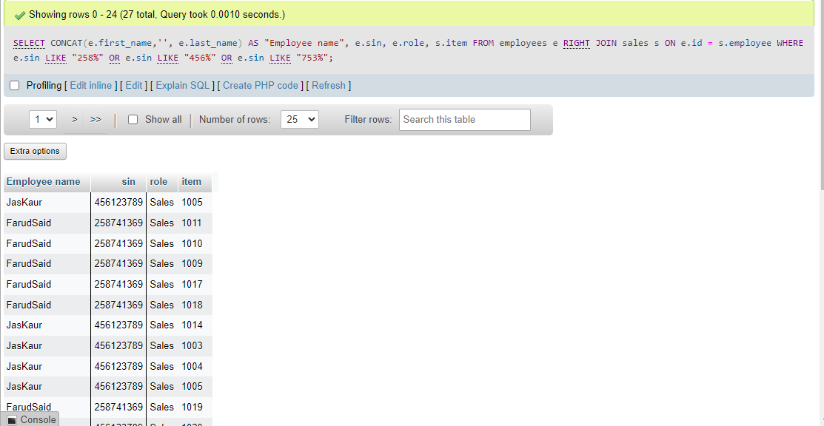

## Part 3: What a week! and Go Team! (1%) sat 12 - fri 18

1. Provide the date, item (from sales), and employee first name for all sales in the range of Saturday June 12 to Friday June 18 (inclusive) of this year.

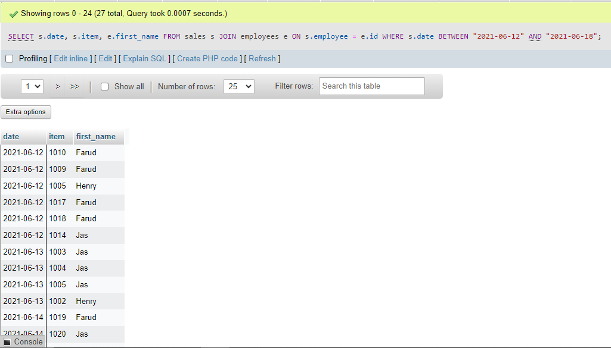

1. Provide the count of all sales for each sales person (first name and last name) grouped by sales person. The results should show most sales to least sales.

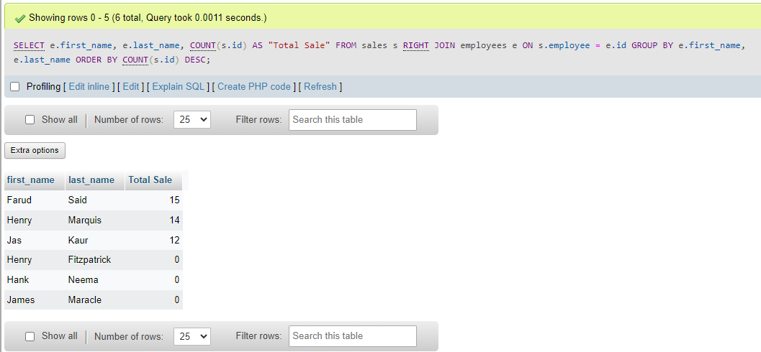

## Part 4: Challenge (1%)

1. *Based on the results from 3B above*, provide the date, item (from stock_items), price, category, and employee first name for all sales of the sales person with the most sales. Use aliases for your tables.

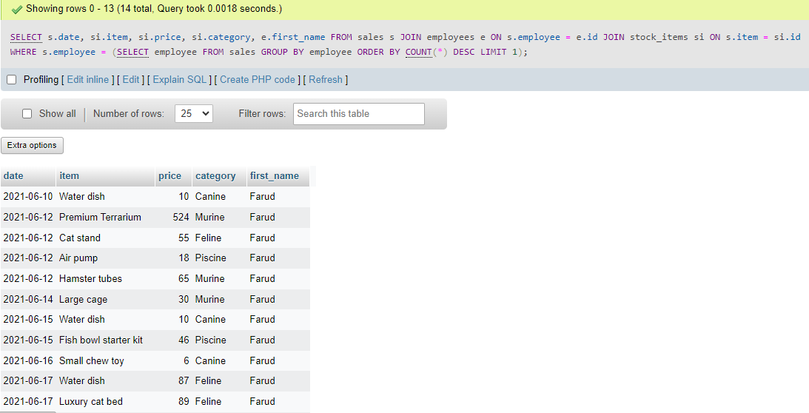

1. Create a list of *unique* items (sales), item id (stock items), items

(stock_items), prices and categories that must include all stock_item items in the result set, whether there were any sales or not. This list should be ordered by the stock_items id.

